Assignment -3
Python Programming

Assignment Date | 6 October 2022
Student Name | Mr. Naveen J
Student Roll Number | 910619104052
Maximum Marks | 2 Marks

Abalone Age Prediction

1. Download the dataset
In [1]:
#Dataset Downloaded

2. Load the Dataset
In [3]:
import numpy as np
import pandas as pd
import matplotlib.pyplot as plt
import seaborn as sns
import warnings
warnings.filterwarnings('ignore')
df = pd.read_csv('abalone.csv')
In [4]:
df.head()
Out[4]:
 | Sex | Length | Diameter | Height | Whole weight | Shucked weight | Viscera weight | Shell weight | Rings
0 | M | 0.455 | 0.365 | 0.095 | 0.5140 | 0.2245 | 0.1010 | 0.150 | 15
1 | M | 0.350 | 0.265 | 0.090 | 0.2255 | 0.0995 | 0.0485 | 0.070 | 7
2 | F | 0.530 | 0.420 | 0.135 | 0.6770 | 0.2565 | 0.1415 | 0.210 | 9
3 | M | 0.440 | 0.365 | 0.125 | 0.5160 | 0.2155 | 0.1140 | 0.155 | 10
4 | I | 0.330 | 0.255 | 0.080 | 0.2050 | 0.0895 | 0.0395 | 0.055 | 7
In [5]:
#Modifying the given dataset
Age=1.5+df.Rings
df["Age"]=Age
df=df.rename(columns = {'Whole weight':'Whole_weight','Shucked weight': 'Shucked_weight','Viscera weight': 'Viscera_weight','Shell weight': 'Shell_weight'})
df=df.drop(columns=["Rings"],axis=1)
df.head()
Out[5]:
 | Sex | Length | Diameter | Height | Whole_weight | Shucked_weight | Viscera_weight | Shell_weight | Age
0 | M | 0.455 | 0.365 | 0.095 | 0.5140 | 0.2245 | 0.1010 | 0.150 | 16.5
1 | M | 0.350 | 0.265 | 0.090 | 0.2255 | 0.0995 | 0.0485 | 0.070 | 8.5
2 | F | 0.530 | 0.420 | 0.135 | 0.6770 | 0.2565 | 0.1415 | 0.210 | 10.5
3 | M | 0.440 | 0.365 | 0.125 | 0.5160 | 0.2155 | 0.1140 | 0.155 | 11.5
4 | I | 0.330 | 0.255 | 0.080 | 0.2050 | 0.0895 | 0.0395 | 0.055 | 8.5
In [6]:
df.tail()
Out[6]:
 | Sex | Length | Diameter | Height | Whole_weight | Shucked_weight | Viscera_weight | Shell_weight | Age
4172 | F | 0.565 | 0.450 | 0.165 | 0.8870 | 0.3700 | 0.2390 | 0.2490 | 12.5
4173 | M | 0.590 | 0.440 | 0.135 | 0.9660 | 0.4390 | 0.2145 | 0.2605 | 11.5
4174 | M | 0.600 | 0.475 | 0.205 | 1.1760 | 0.5255 | 0.2875 | 0.3080 | 10.5
4175 | F | 0.625 | 0.485 | 0.150 | 1.0945 | 0.5310 | 0.2610 | 0.2960 | 11.5
4176 | M | 0.710 | 0.555 | 0.195 | 1.9485 | 0.9455 | 0.3765 | 0.4950 | 13.5
In [7]:
df.shape
Out[7]:
(4177, 9)
In [8]:
df.info()
<class 'pandas.core.frame.DataFrame'>
RangeIndex: 4177 entries, 0 to 4176
Data columns (total 9 columns):
# Column Non-Null Count Dtype
--- ------ -------------- -----
0 Sex 4177 non-null object
1 Length 4177 non-null float64
2 Diameter 4177 non-null float64
3 Height 4177 non-null float64
4 Whole_weight 4177 non-null float64
5 Shucked_weight 4177 non-null float64
6 Viscera_weight 4177 non-null float64
7 Shell_weight 4177 non-null float64
8 Age 4177 non-null float64
dtypes: float64(8), object(1)
memory usage: 293.8+ KB

3. Perform Visualizations

Univariate Analysis
In [10]:
sns.countplot(x='Sex',data=df)
Out[10]:
<AxesSubplot:xlabel='Sex', ylabel='count'>
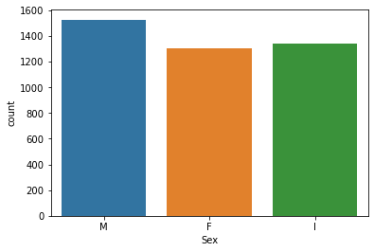
In [12]:
sns.displot(df["Length"])
Out[12]:
<seaborn.axisgrid.FacetGrid at 0x2d750617c10>
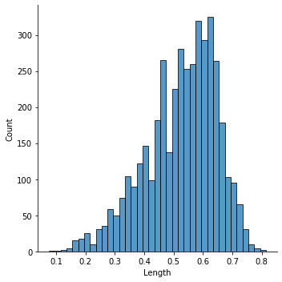
In [13]:
sns.histplot(x='Height',data=df)
Out[13]:
<AxesSubplot:xlabel='Height', ylabel='Count'>
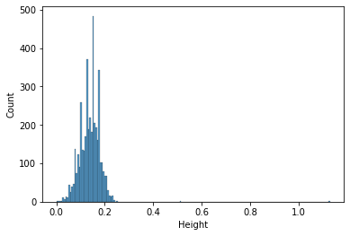
In [15]:
sns.boxplot(df["Age"],color='red')
Out[15]:
<AxesSubplot:xlabel='Age'>
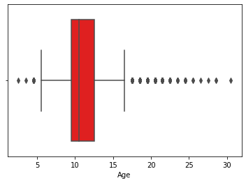

Bivariate Analysis
In [17]:
sns.barplot(x=df["Height"],y=df["Whole_weight"])
Out[17]:
<AxesSubplot:xlabel='Height', ylabel='Whole_weight'>
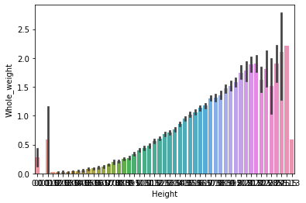
In [21]:
plt.scatter(df['Height'], df['Age'], c='red')
plt.xlabel('Height of abalone (mm)')
plt.ylabel('Age')
plt.show()
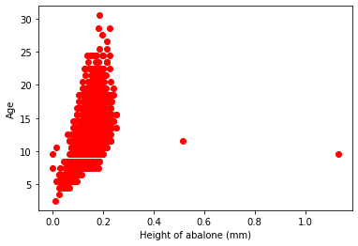
In [20]:
plt.scatter(df['Length'], df['Age'], c='green')
plt.xlabel('Length of abalone (mm)')
plt.ylabel('Age')
plt.show()
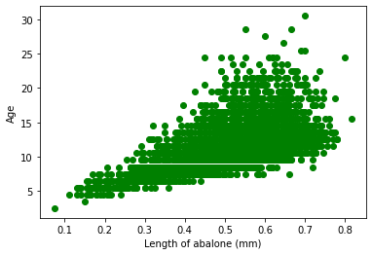
In [23]:
plt.scatter(df['Diameter'], df['Age'],c='brown')
plt.xlabel('Height of abalone (mm)')
plt.ylabel('Age')
plt.show()
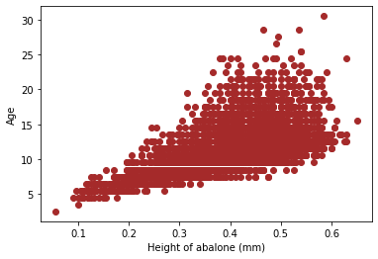

Multi-Variate Analysis
In [24]:
sns.pairplot(df,hue='Sex')
Out[24]:
<seaborn.axisgrid.PairGrid at 0x2d752e146d0>
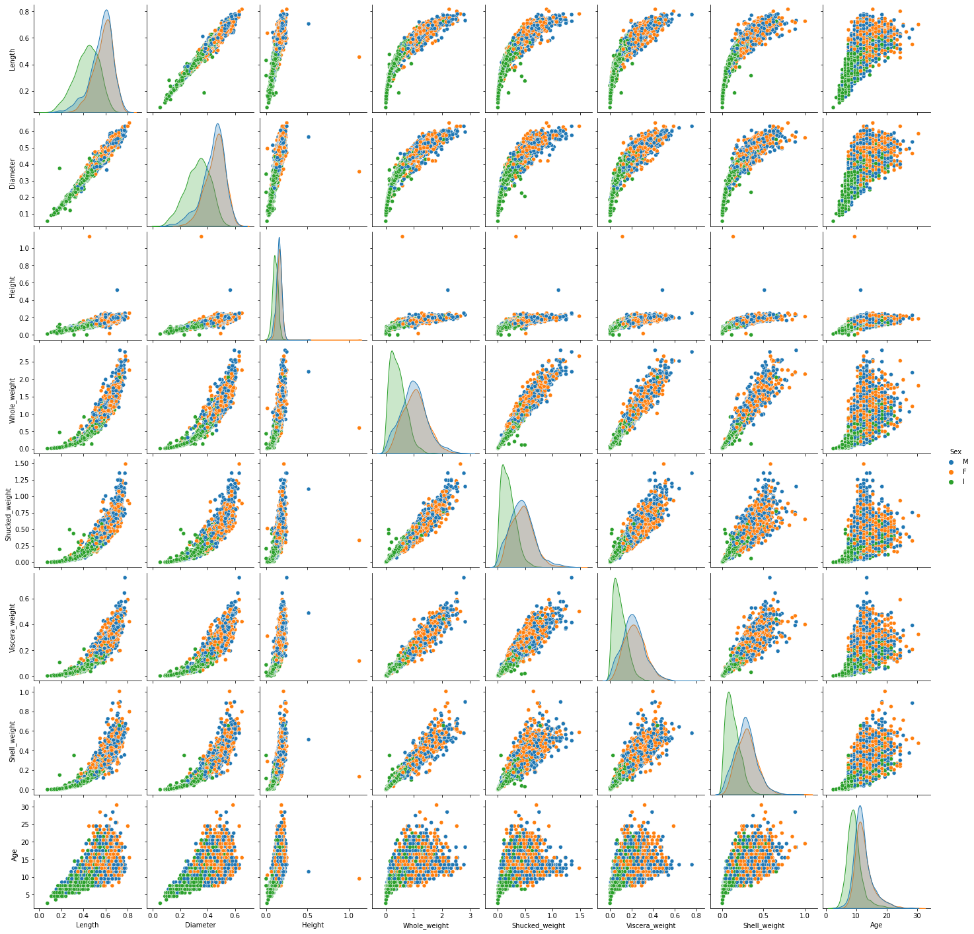
In [25]:
plt.figure(figsize=(12,8));
sns.heatmap(df.corr(), cmap="PiYG",annot=True);
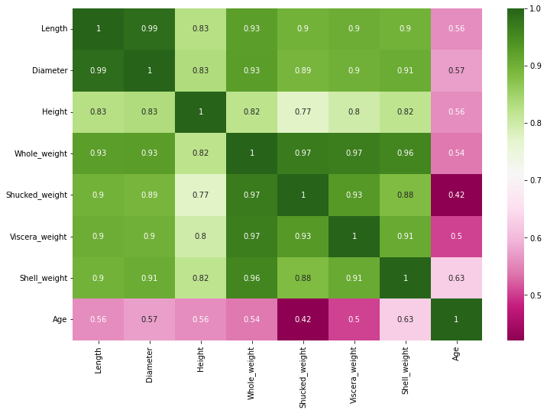

4.Descriptive statistics
In [27]:
df.describe(include='all')
Out[27]:
 | Sex | Length | Diameter | Height | Whole_weight | Shucked_weight | Viscera_weight | Shell_weight | Age
count | 4177 | 4177.000000 | 4177.000000 | 4177.000000 | 4177.000000 | 4177.000000 | 4177.000000 | 4177.000000 | 4177.000000
unique | 3 | NaN | NaN | NaN | NaN | NaN | NaN | NaN | NaN
top | M | NaN | NaN | NaN | NaN | NaN | NaN | NaN | NaN
freq | 1528 | NaN | NaN | NaN | NaN | NaN | NaN | NaN | NaN
mean | NaN | 0.523992 | 0.407881 | 0.139516 | 0.828742 | 0.359367 | 0.180594 | 0.238831 | 11.433684
std | NaN | 0.120093 | 0.099240 | 0.041827 | 0.490389 | 0.221963 | 0.109614 | 0.139203 | 3.224169
min | NaN | 0.075000 | 0.055000 | 0.000000 | 0.002000 | 0.001000 | 0.000500 | 0.001500 | 2.500000
25% | NaN | 0.450000 | 0.350000 | 0.115000 | 0.441500 | 0.186000 | 0.093500 | 0.130000 | 9.500000
50% | NaN | 0.545000 | 0.425000 | 0.140000 | 0.799500 | 0.336000 | 0.171000 | 0.234000 | 10.500000
75% | NaN | 0.615000 | 0.480000 | 0.165000 | 1.153000 | 0.502000 | 0.253000 | 0.329000 | 12.500000
max | NaN | 0.815000 | 0.650000 | 1.130000 | 2.825500 | 1.488000 | 0.760000 | 1.005000 | 30.500000

5. Check for Missing values and deal with them
In [29]:
df.isnull().sum()
Out[29]:
Sex 0
Length 0
Diameter 0
Height 0
Whole_weight 0
Shucked_weight 0
Viscera_weight 0
Shell_weight 0
Age 0
dtype: int64

6. Find the outliers and replacing them outliers
In [30]:
col =['Length', 'Diameter', 'Height', 'Whole_weight', 'Shucked_weight',
'Viscera_weight', 'Shell_weight', 'Age']
In [31]:
figfig, axes = plt.subplots(4,2,figsize=(16, 14))
axes = np.ravel(axes)
for i, c in enumerate(col):
hist = df[c].plot(kind = 'box', ax=axes[i],color='green', vert=False)
axes[i].set_title(c, fontsize=15)

plt.tight_layout()
plt.show()
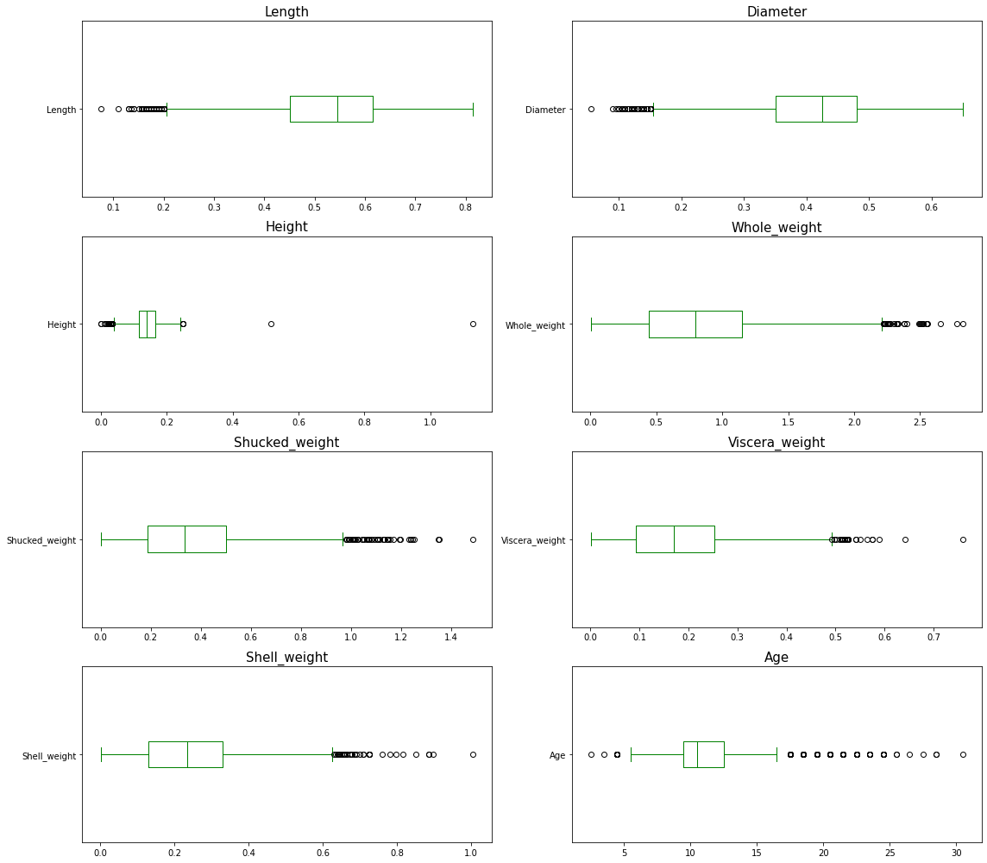
In [32]:
qnt = df.quantile([0.75,0.25])
qnt
Out[32]:
 | Length | Diameter | Height | Whole_weight | Shucked_weight | Viscera_weight | Shell_weight | Age
0.75 | 0.615 | 0.48 | 0.165 | 1.1530 | 0.502 | 0.2530 | 0.329 | 12.5
0.25 | 0.450 | 0.35 | 0.115 | 0.4415 | 0.186 | 0.0935 | 0.130 | 9.5
In [34]:
IQR = qnt.loc[0.75] - qnt.loc[0.25]
IQR
Out[34]:
Length 0.1650
Diameter 0.1300
Height 0.0500
Whole_weight 0.7115
Shucked_weight 0.3160
Viscera_weight 0.1595
Shell_weight 0.1990
Age 3.0000
dtype: float64
In [35]:
lower = qnt.loc[0.25] - 1.5 * IQR
lower
Out[35]:
Length 0.20250
Diameter 0.15500
Height 0.04000
Whole_weight -0.62575
Shucked_weight -0.28800
Viscera_weight -0.14575
Shell_weight -0.16850
Age 5.00000
dtype: float64
In [36]:
upper = qnt.loc[0.75] + 1.5 * IQR
upper
Out[36]:
Length 0.86250
Diameter 0.67500
Height 0.24000
Whole_weight 2.22025
Shucked_weight 0.97600
Viscera_weight 0.49225
Shell_weight 0.62750
Age 17.00000
dtype: float64
In [37]:
df.mean()
Out[37]:
Length 0.523992
Diameter 0.407881
Height 0.139516
Whole_weight 0.828742
Shucked_weight 0.359367
Viscera_weight 0.180594
Shell_weight 0.238831
Age 11.433684
dtype: float64
In [38]:
df['Length']=np.where(df['Length']<0.22,0.52,df['Length'])
df['Diameter']=np.where(df['Diameter']<0.155,0.407,df['Diameter'])
df['Height']=np.where(df['Height']<0.04,0.13,df['Height'])
In [39]:
df['Height']=np.where(df['Height']>0.24,0.13,df['Height'])
df['Whole_weight']=np.where(df['Whole_weight']>2.18,0.83,df['Whole_weight'])
df['Shucked_weight']=np.where(df['Shucked_weight']>0.958,0.359367,df['Shucked_weight'])
df['Viscera_weight']=np.where(df['Viscera_weight']>0.478,0.18,df['Viscera_weight'])
In [40]:
df['Shell_weight']=np.where(df['Shell_weight']>0.61,0.238831,df['Shell_weight'])
df['Age']=np.where(df['Age']<5.0,11.43,df['Age'])
df['Age']=np.where(df['Age']>17.0,11.43,df['Age'])
In [41]:
figfig, axes = plt.subplots(4,2,figsize=(16, 14))
axes = np.ravel(axes)

for i, c in enumerate(col):
hist = df[c].plot(kind = 'box', ax=axes[i],color='blue', vert=False)
axes[i].set_title(c, fontsize=15)

plt.tight_layout()
plt.show()
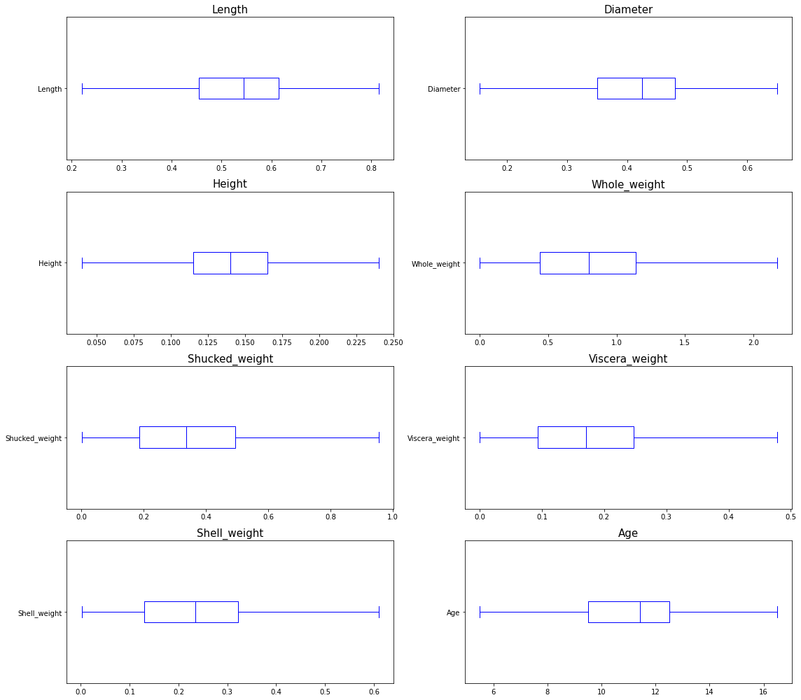
In [42]:
df.shape
Out[42]:
(4177, 9)

7. Check for Categorical columns and perform encoding
In [43]:
df['Sex'].unique()
Out[43]:
array(['M', 'F', 'I'], dtype=object)
In [44]:
x = pd.get_dummies(df)
In [45]:
x.head()
Out[45]:
 | Length | Diameter | Height | Whole_weight | Shucked_weight | Viscera_weight | Shell_weight | Age | Sex_F | Sex_I | Sex_M
0 | 0.455 | 0.365 | 0.095 | 0.5140 | 0.2245 | 0.1010 | 0.150 | 16.5 | 0 | 0 | 1
1 | 0.350 | 0.265 | 0.090 | 0.2255 | 0.0995 | 0.0485 | 0.070 | 8.5 | 0 | 0 | 1
2 | 0.530 | 0.420 | 0.135 | 0.6770 | 0.2565 | 0.1415 | 0.210 | 10.5 | 1 | 0 | 0
3 | 0.440 | 0.365 | 0.125 | 0.5160 | 0.2155 | 0.1140 | 0.155 | 11.5 | 0 | 0 | 1
4 | 0.330 | 0.255 | 0.080 | 0.2050 | 0.0895 | 0.0395 | 0.055 | 8.5 | 0 | 1 | 0

8. Split the data into dependent and independent variables
In [46]:
x.info()
<class 'pandas.core.frame.DataFrame'>
RangeIndex: 4177 entries, 0 to 4176
Data columns (total 11 columns):
# Column Non-Null Count Dtype
--- ------ -------------- -----
0 Length 4177 non-null float64
1 Diameter 4177 non-null float64
2 Height 4177 non-null float64
3 Whole_weight 4177 non-null float64
4 Shucked_weight 4177 non-null float64
5 Viscera_weight 4177 non-null float64
6 Shell_weight 4177 non-null float64
7 Age 4177 non-null float64
8 Sex_F 4177 non-null uint8
9 Sex_I 4177 non-null uint8
10 Sex_M 4177 non-null uint8
dtypes: float64(8), uint8(3)
memory usage: 273.4 KB
In [47]:
X = x.drop(['Age'], axis = 1)
In [48]:
X.head()
Out[48]:
 | Length | Diameter | Height | Whole_weight | Shucked_weight | Viscera_weight | Shell_weight | Sex_F | Sex_I | Sex_M
0 | 0.455 | 0.365 | 0.095 | 0.5140 | 0.2245 | 0.1010 | 0.150 | 0 | 0 | 1
1 | 0.350 | 0.265 | 0.090 | 0.2255 | 0.0995 | 0.0485 | 0.070 | 0 | 0 | 1
2 | 0.530 | 0.420 | 0.135 | 0.6770 | 0.2565 | 0.1415 | 0.210 | 1 | 0 | 0
3 | 0.440 | 0.365 | 0.125 | 0.5160 | 0.2155 | 0.1140 | 0.155 | 0 | 0 | 1
4 | 0.330 | 0.255 | 0.080 | 0.2050 | 0.0895 | 0.0395 | 0.055 | 0 | 1 | 0
In [49]:
y = x['Age']
In [50]:
y.head()
Out[50]:
0 16.5
1 8.5
2 10.5
3 11.5
4 8.5
Name: Age, dtype: float64

9. Scale the independent variables
In [51]:
from sklearn.preprocessing import StandardScaler
In [52]:
X_columns = X.select_dtypes(include=np.number).columns.tolist()
X_columns
Out[52]:
['Length',
'Diameter',
'Height',
'Whole_weight',
'Shucked_weight',
'Viscera_weight',
'Shell_weight',
'Sex_F',
'Sex_I',
'Sex_M']
In [53]:
scaler = StandardScaler()
In [54]:
X[X_columns] = scaler.fit_transform(X[X_columns])
X.head()
Out[54]:
 | Length | Diameter | Height | Whole_weight | Shucked_weight | Viscera_weight | Shell_weight | Sex_F | Sex_I | Sex_M
0 | -0.663474 | -0.501673 | -1.196422 | -0.643390 | -0.611770 | -0.732343 | -0.643590 | -0.674834 | -0.688018 | 1.316677
1 | -1.601273 | -1.572915 | -1.330241 | -1.259765 | -1.219694 | -1.236126 | -1.257424 | -0.674834 | -0.688018 | 1.316677
2 | 0.006383 | 0.087510 | -0.125873 | -0.295144 | -0.456142 | -0.343709 | -0.183214 | 1.481846 | -0.688018 | -0.759488
3 | -0.797445 | -0.501673 | -0.393511 | -0.639118 | -0.655541 | -0.607596 | -0.605225 | -0.674834 | -0.688018 | 1.316677
4 | -1.779901 | -1.680039 | -1.597878 | -1.303563 | -1.268328 | -1.322489 | -1.372518 | -0.674834 | 1.453451 | -0.759488

10. Split the data into training and testing
In [55]:
X.shape, y.shape
Out[55]:
((4177, 10), (4177,))
In [56]:
from sklearn.model_selection import train_test_split
x_train, x_test, y_train, y_test = train_test_split(X,y, test_size=0.2, random_state=42)
In [57]:
print(' x_train.shape : ',x_train.shape)
print(' y_train.shape : ',y_train.shape)
print(' x_test.shape : ',x_test.shape)
print(' y_test.shape : ',y_test.shape)
x_train.shape : (3341, 10)
y_train.shape : (3341,)
x_test.shape : (836, 10)
y_test.shape : (836,)

Build the Model, Train the Model and Test the Model
In [58]:
#Linear Regression
from sklearn.linear_model import LinearRegression

lr = LinearRegression()
lr.fit(x_train, y_train)

lr_pred = lr.predict(x_test)
In [59]:
#Random Forest
from sklearn.ensemble import RandomForestRegressor
from sklearn.metrics import mean_squared_error,make_scorer
from sklearn.model_selection import RandomizedSearchCV

rf = RandomForestRegressor()

param = {
'max_depth':[3,6,9,12,15],
'n_estimators' : [10,50,100,150,200]
}

rf_search = RandomizedSearchCV(rf,param_distributions=param,n_iter=5,scoring=make_scorer(mean_squared_error),
n_jobs=-1,cv=5,verbose=3)

rf_search.fit(x_train, y_train)
Fitting 5 folds for each of 5 candidates, totalling 25 fits
Out[59]:
RandomizedSearchCV(cv=5, estimator=RandomForestRegressor(), n_iter=5, n_jobs=-1,
param_distributions={'max_depth': [3, 6, 9, 12, 15],
'n_estimators': [10, 50, 100, 150,
200]},
scoring=make_scorer(mean_squared_error), verbose=3)
In [60]:
#In a Jupyter environment, please rerun this cell to show the HTML representation or trust the notebook.
#On GitHub, the HTML representation is unable to render, please try loading this page with nbviewer.org.
In [61]:
means = rf_search.cv_results_['mean_test_score']
params = rf_search.cv_results_['params']
for mean, param in zip(means, params):
print("%f with: %r" % (mean, param))
if mean == min(means):
print('Best parameters with the minimum Mean Square Error are:',param)
2.753132 with: {'n_estimators': 50, 'max_depth': 12}
2.644186 with: {'n_estimators': 200, 'max_depth': 6}
2.640827 with: {'n_estimators': 50, 'max_depth': 6}
Best parameters with the minimum Mean Square Error are: {'n_estimators': 50, 'max_depth': 6}
2.762468 with: {'n_estimators': 50, 'max_depth': 15}
2.739511 with: {'n_estimators': 200, 'max_depth': 15}
In [62]:
rf = RandomForestRegressor(n_estimators=50, max_depth=6)
rf.fit(x_train,y_train)

rf_pred = rf.predict(x_test)

14. Measure the performance using Metrics
In [64]:
from sklearn import metrics
RMSE1 = np.sqrt(metrics.mean_squared_error(y_test, lr_pred))
MAE = metrics.mean_absolute_error(y_test, lr_pred)
MSE = metrics.mean_squared_error(y_test, lr_pred)
R2 = metrics.r2_score(y_test,lr_pred)
print('Linear Regression :')
print('-------------------')
print('MAE:', MAE)
print('MSE:', MSE)
print('RMSE:', RMSE1)
print('R2 Score :',R2)
print('\n\n')
Linear Regression :
-------------------
MAE: 1.326777442258078
MSE: 2.9868483619389266
RMSE: 1.7282500866306725
R2 Score : 0.4466536519118789

In [65]:
from sklearn import metrics
RMSE2 = np.sqrt(metrics.mean_squared_error(y_test, rf_pred))
MAE = metrics.mean_absolute_error(y_test, rf_pred)
MSE = metrics.mean_squared_error(y_test, rf_pred)
R2 = metrics.r2_score(y_test,rf_pred)
print('Random Forest Contains:')
print('-------------------')
print('MAE:', MAE)
print('MSE:', MSE)
print('RMSE:', RMSE2)
print('R2 Score :',R2)
Random Forest Contains:
-------------------
MAE: 1.2369731265164512
MSE: 2.5047280907807443
RMSE: 1.5826332774148104
R2 Score : 0.5359717086248263

Compare Linear Regression and Random Forest

Random Forest got low rmse value than Linear Regression
In [66]:
RMSE = RMSE1-RMSE2
print(RMSE)
0.14561680921586206
In [ ]:

